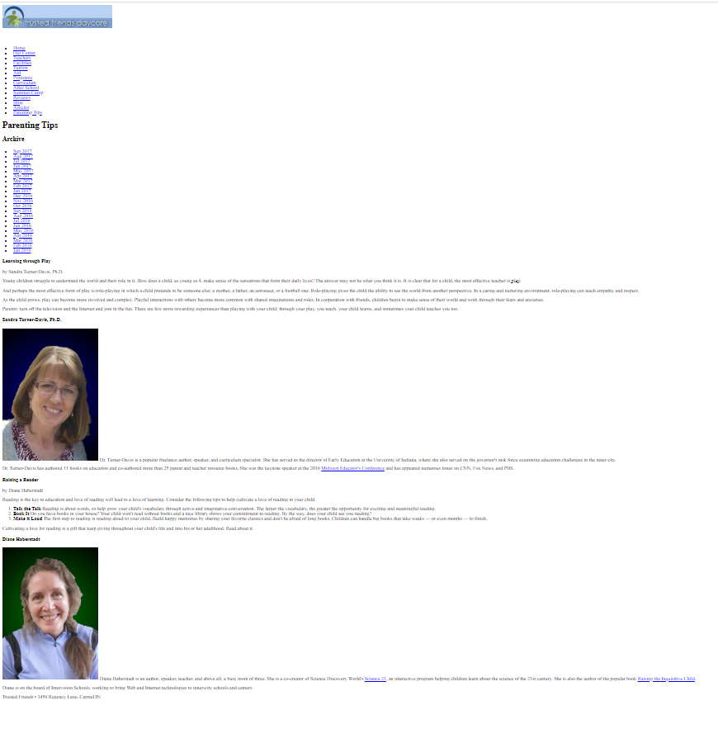

section class="tips"

footer

section class="tips"

section id="right"

section id="left"

article

aside

aside

article

header

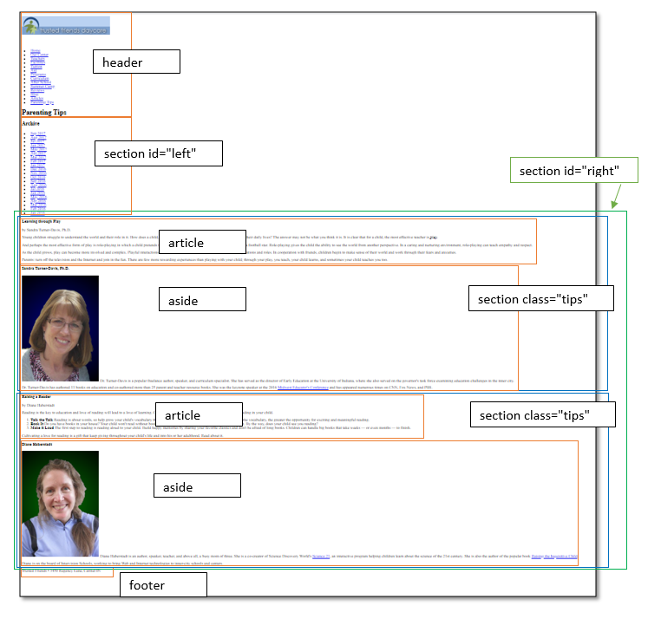



section id="left"

flex: 1 8 130px

section id="right"

flex: 8 1 351px;

section.tips {

display: flex;

flex-flow: row wrap; }

article { flex: 2 1 351px;}

aside { flex: 1 2 250px;}

body

body {

display: flex;

flex-flow: row wrap;}

header, footer { width: 100%;}

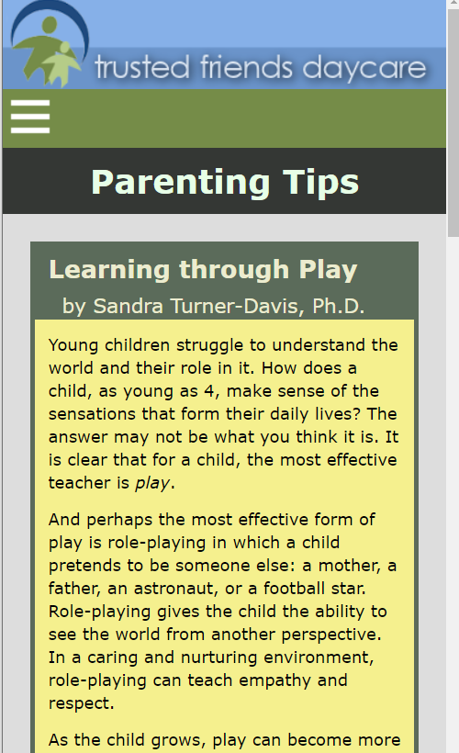

section id="left" flex: 1 8 130px

section id="right"

flex: 8 1 351px;

section.tips {

display: flex;

flex-flow: row wrap; }

article {flex: 2 1 351px;}

aside { flex: 1 2 250px;}

body { display: flex;

flex-flow: row wrap;}

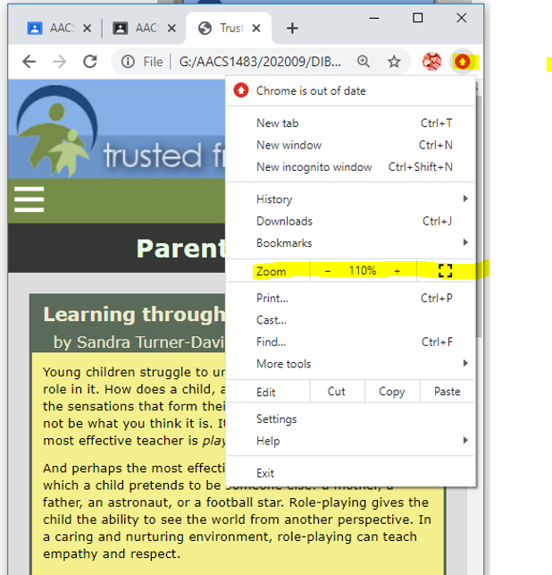

desktop version

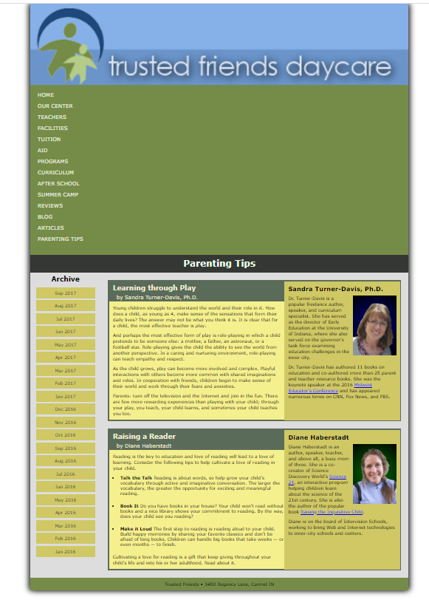

nav.horizontal ul{ display: flex; flex-flow: column wrap;}

======  
@media only screen and (min-width: 481px) {

/* Header Navigation Styles */

body > header > nav.horizontal > ul { height: 160px; }

}

mobile version

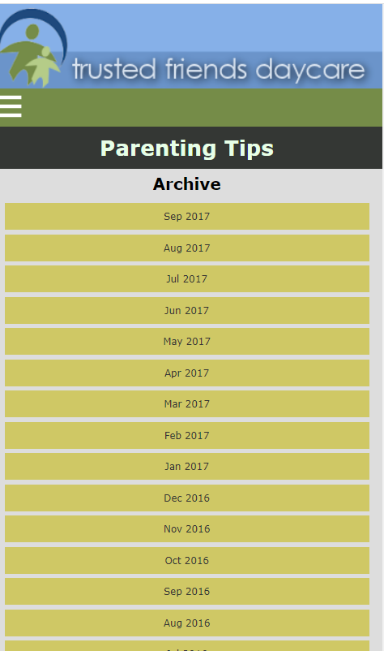 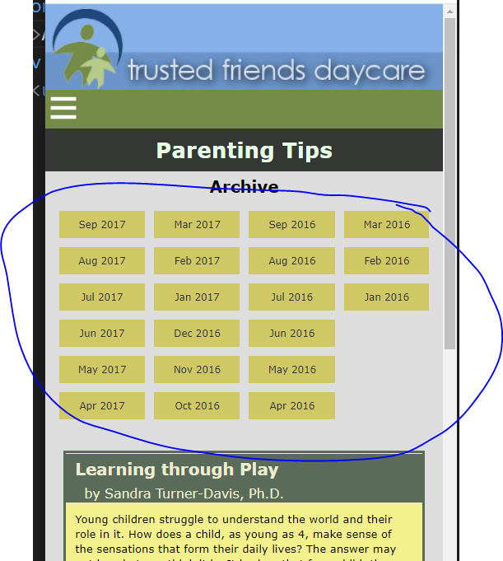

/* Mobile Flex Styles */

nav.vertical ul { display: flex; flex-flow: column wrap; height: 240px; }

mobile version

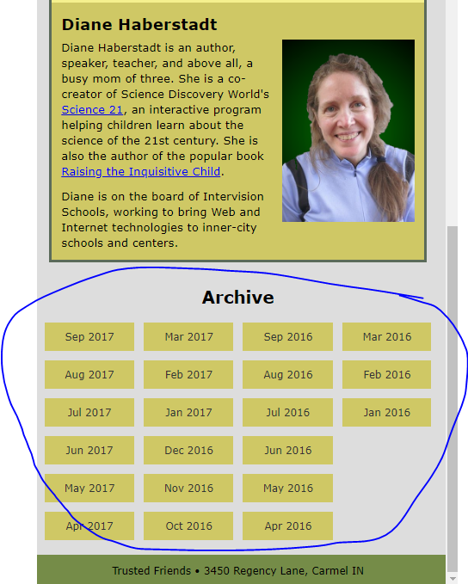

section#left { order: 99; }

body > footer { order: 100; }

desktop version



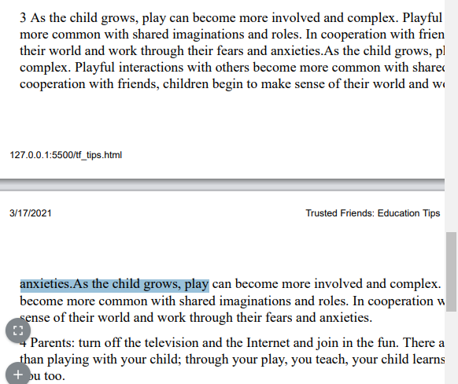

P {orphan:2; }

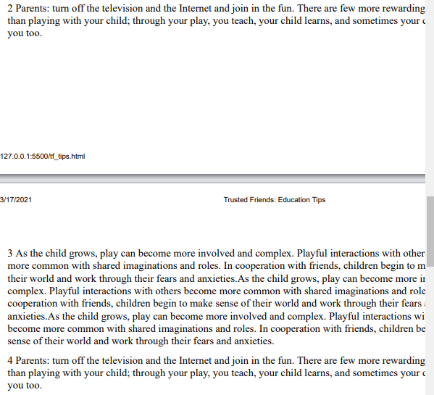

P {orphan:10; }

**https://www.w3schools.com/jsref/tryjsref_style_orphans.htm**